Smart Irrigation System
And Irrigation Water Requirement Prediction
Shihao Xu, Lingqi Meng
University of Massachusetts Amherst

Abstract—The widespread use of the Internet of Things in agriculture has profoundly affected the way agriculture works. We use IoT technology to predict the amount of irrigation on the farm by using various weather data and irrigation data collected by the farm. Predictive results can be used to understand irrigation and save water. After we got datasets, we combine them into a training dataset, and our system predict daily water usage by applying different machine learning models on our training dataset. According to this project, farm can access a way to make prediction of daily water usage.

Keywords— IoT, irrigation water usage, weather information, machine learning, prediction
- Introduction
Nowadays, Farming accounts for about 70% of the water consumed all over the world and most of its wasteful use. Wasted irrigation is a common phenomenon throughout the world. However more water always cause some problem in irrigation, over irrigation will increases the amount of salt on the surface of soil due to water evaporation. The accumulation of salts will damage the soil fertility and the worst case is saline-alkali soil. Saline-alkali soil leads to a reduction in farm grain output, directly affecting the economic benefits of the farm, many farms are facing such problems, thus the concept of precision irrigation is becoming more and more popular and important. According to data collected by sensors (Max and Min temperature, rainfall, radiation, etc.), we predict how much water will be irrigated. In this way, we can make irrigation more controllable and accurate.
- Study Area
Our study area is Coleambally Irrigation Area (CIA). CIA is one of the most modernized irrigation areas in the Australia, and applies modern agriculture, which is good for us to collect data.
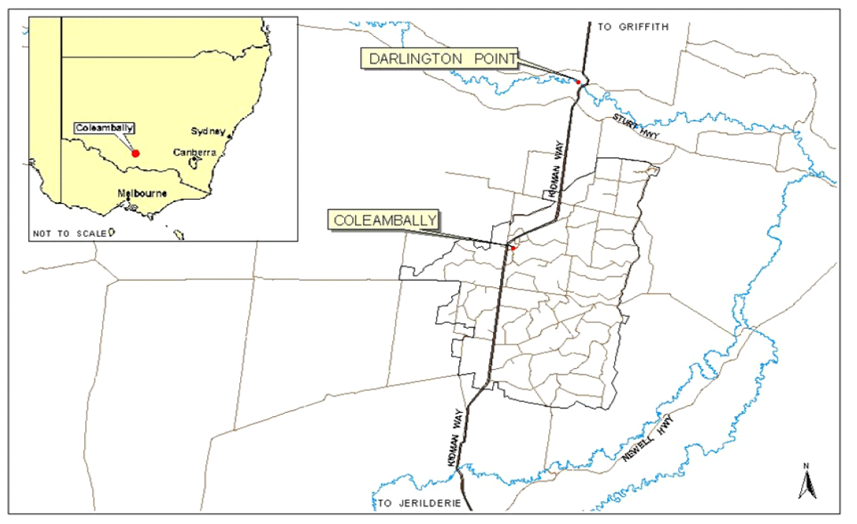
Fig. 1 location of Coleambally Irrigation Area
- Coleambally Irrigation Area
Coleambally Irrigation Area is selected since we can easily access the crop information and monthly water usage by its annual reports. we can collect Coleambally weather information from Bureau of Meteorology Australian Government.

- Data Pre-processing
There is a challenge when we prepare the dataset, that is how to get daily water usage. We know that farm don’t take water supply every day, instead, it takes a delivery of water on a day in a month and uses the water for a time span, so we just can access monthly water usage by annual reports from Coleambally Irrigation Area (CIA).
- Plans of calculating daily water usage data
There is a challenge when we prepare the training dataset, that is how to get daily water usage. We know that farm don’t take water supply every day, instead, it takes a delivery of water on a day in a month and uses the water for a time span, so we just can access monthly water usage by annual reports from Coleambally Irrigation Area (CIA). For solving this problem, we tried two plans: average water usage and evapotranspiration calculation.
Plan 1: Average water usage as daily water usage, we can get monthly water usage, so we can get average in this month, and use it as the daily water usage, but this plan is not good. We can find out an obvious reason, if we divide the water usage equally, then water usage will always be the same for each day regardless of the weather conditions. Our system can learn little thing from a dataset like this, so we didn’t choose this plan in our project.
Plan 2: calculate daily water usage by evapotranspiration, in this plan, we take reference evapotranspiration (ETo) factor into consideration. Crop water usage which is the product of crop coefficient Kc and reference evapotranspiration (ETo). We have the equation: Water demand = ETo * Kc. Each crop has a constant crop coefficient value for a specific growth stage ^{[1]}. We don’t have the value here, because we just use the ratios here to calculate our daily water usage by following variables and equation:
- n be the number of days in a farm
- Wt be the amount of water delivered in a month
- Wi be the water usage in the i th day
- Eto be the daily reference evapotranspiration
- Etoi is the ETo of the i th day
- xi be the water usage coefficient in the i th day
- Equation:
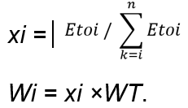

- Calculate reference evapotranspiration
There are different models can be used to calculate Reference Evapotranspiration by different parameters, such as, FAO Penman-Monteith, Baler-Robertson, and Hargreaves-Samani Model ^{[2]}. But we should choose a model according to the parameters, which we can access in our study area.
In our project, according to the parameters that we can access, our choice is Hargreaves-Samani Model ^{[3]}:

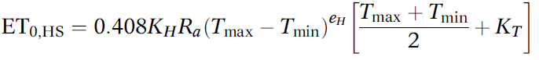
Because we can access maximum and minimum temperature and daily radiation and we the values of coefficients, KH =0.0023, KT =17.8, and eH =0.5. we can use the equation on weather dataset to calculate reference evapotranspiration
- Machine Learning Model
- Feature and label processing
As we know, there are a lot of factors will impact water daily usage of crops, then we choose five obvious factors work as features. The details of features are listed in table 1.

Table 1: Features of Experts
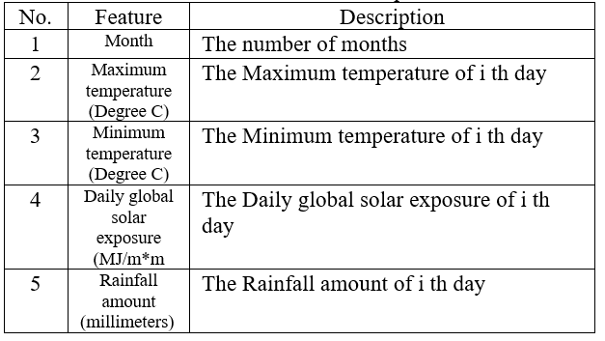
We have calculated the daily water usage Wi of three crops in data pre-processing part, and three crops daily water usage will work as three labels ^{[4]}.
- Machine Learning regressor
In this study, we use linear model, decision tree, KNN and Support vector machine to predict the daily water usage of three different crops.
To determine the success of different model, we perform a 5-fold cross validation to achieve measurements of MAE (Mean Absolute Error).
We use 5-fold cross validation to split feature and labels into five parts, then we use four parts of them worked as training data and the one part left will work as test data. The advantage of this method over repeated random sub-sampling is that all observations are used for both training and validation, and each observation is used for validation exactly once^{[5]}.
We use MAE to measure which model works better than other models.
y_{i} is the prediction value
x_{i} is the label value
n is the numbers of labels
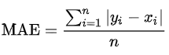
Generally, the lower MAE value means the prediction is closer to reall value. We can say this model works well on this dataset.
- experiment and result
We get the prediction of rice daily water usage on four different models to compare which model works better.
For showing clearly, we calculate the monthly water usage based on the daily water usage.
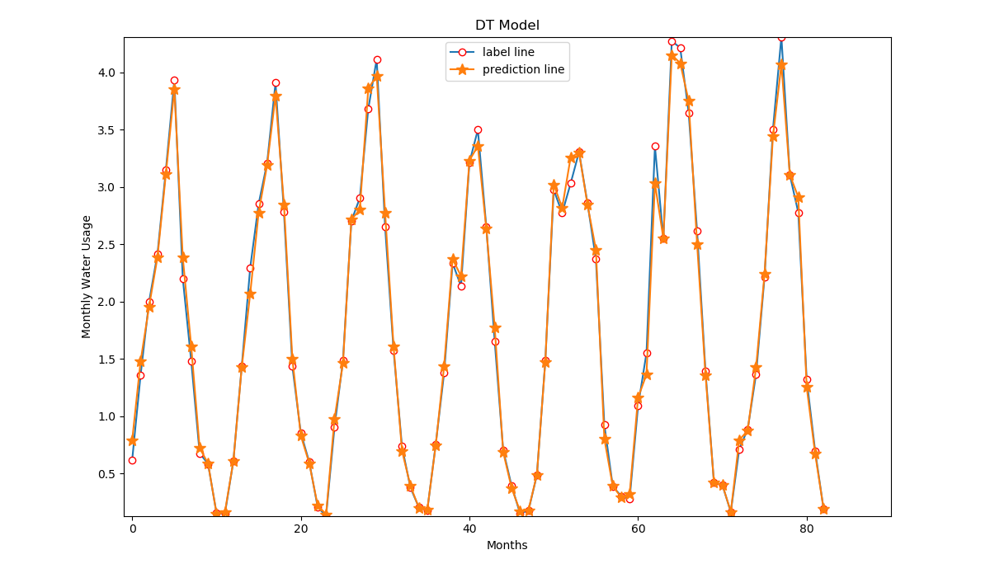
Fig. 2 Line chart of decision tree
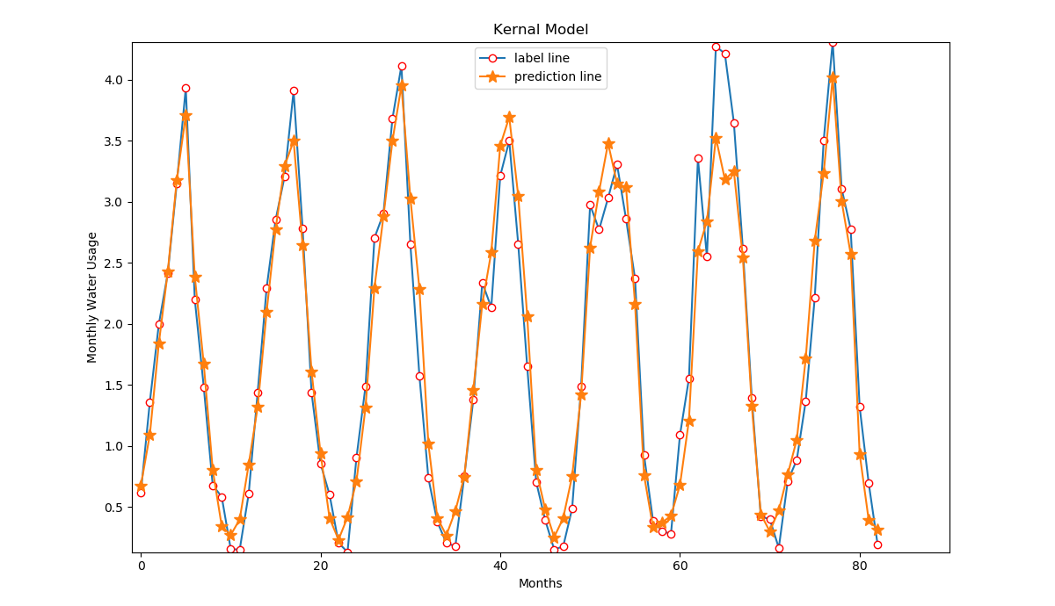
Fig. 3 Line chart of SVM
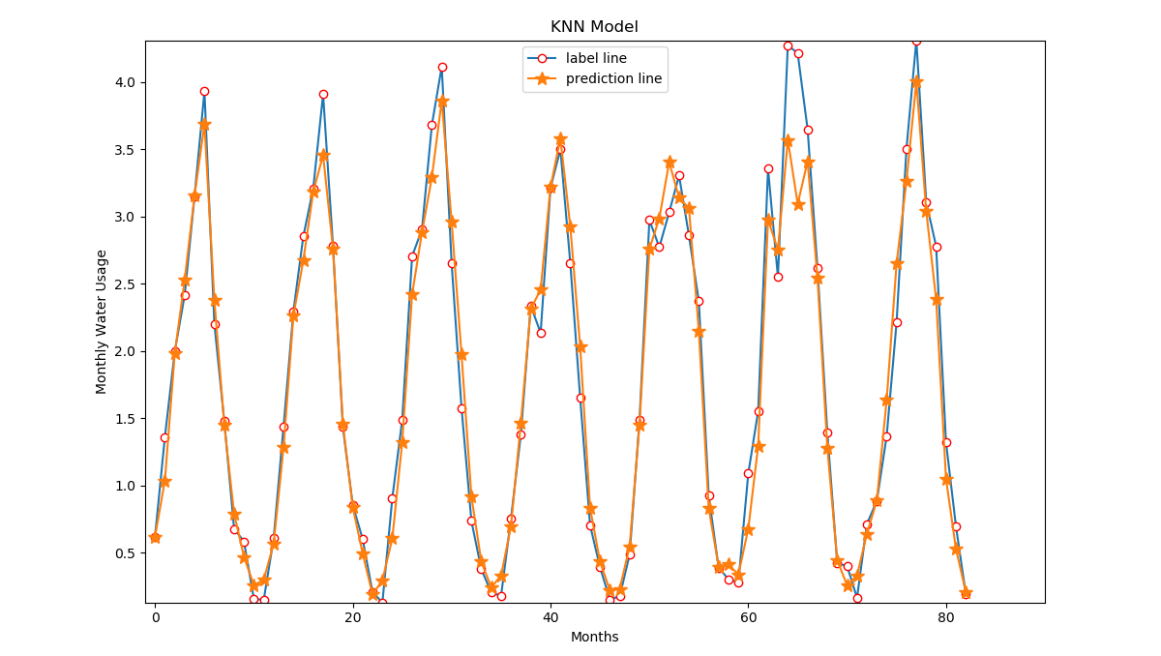
Fig. 4 Line chart of KNN
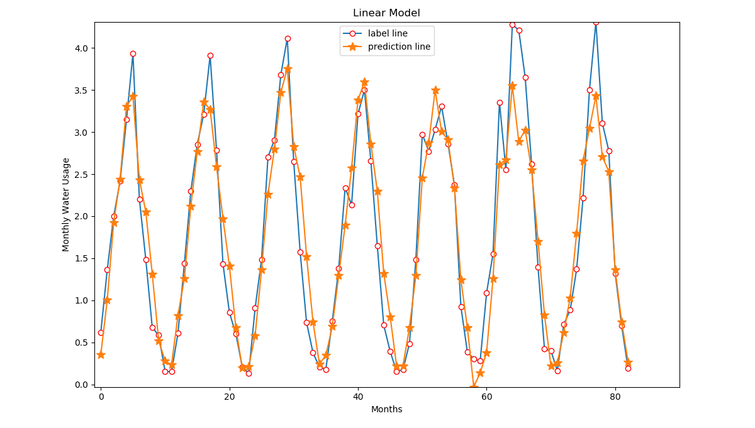
Fig. 5 Line chart of linear model

Also, we calculate MAE values of each model. According to MAE values shown in table 2, we decide which model we will choose.
Table 2: 5-fold cross validation MAE values
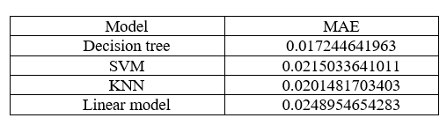
After measurement, we see that decision tree works better than KNN, linear model and SVM, so we only present the prediction of three crops coming from decision tree model shown in Fig.5, Fig.6 and Fig.7.
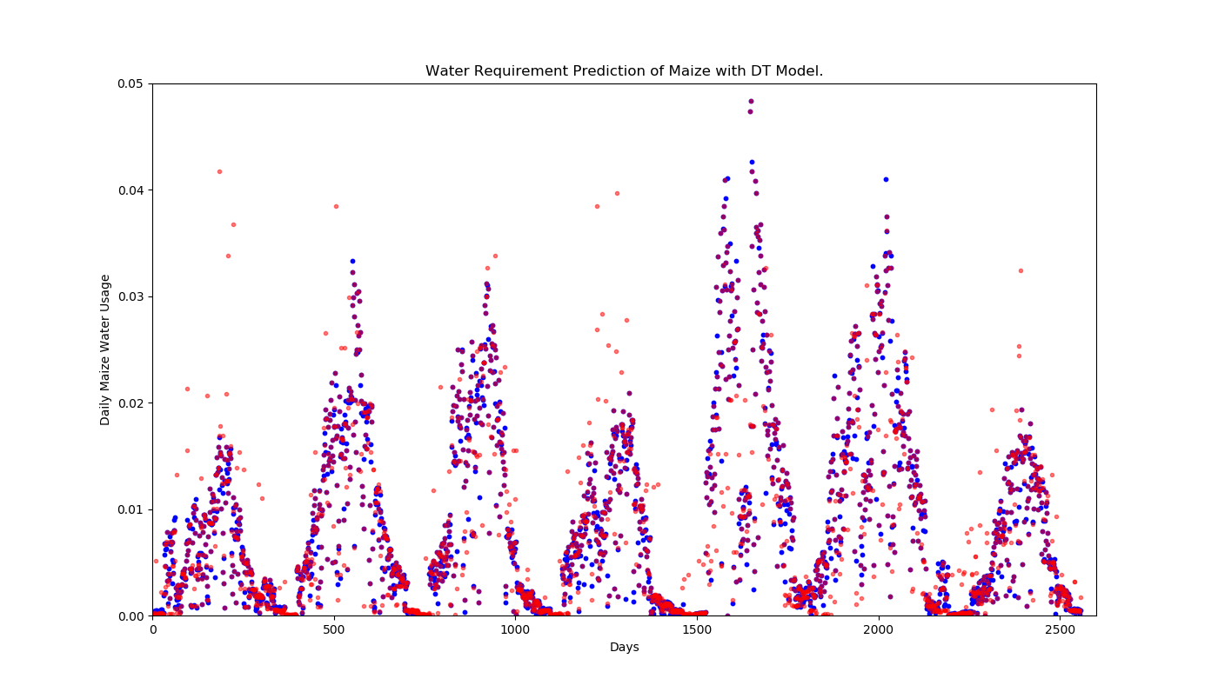
Fig. 5 Prediction of maize with decision tree model
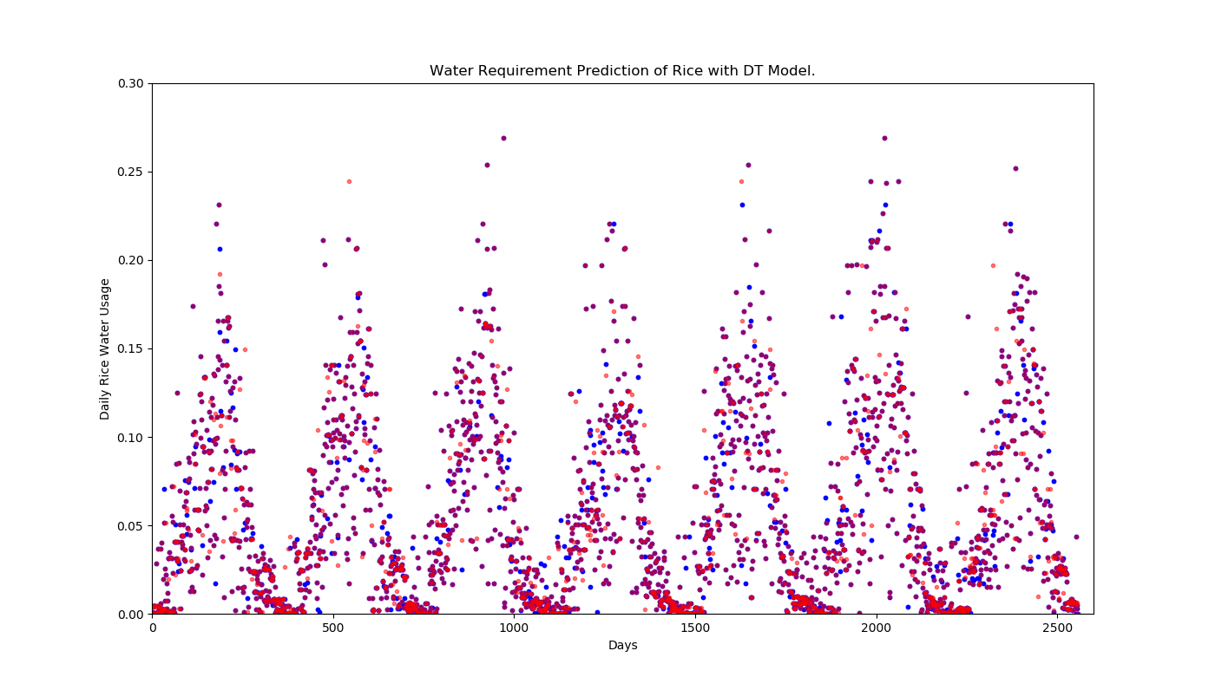
Fig. 6 Prediction of rice with decision tree mode
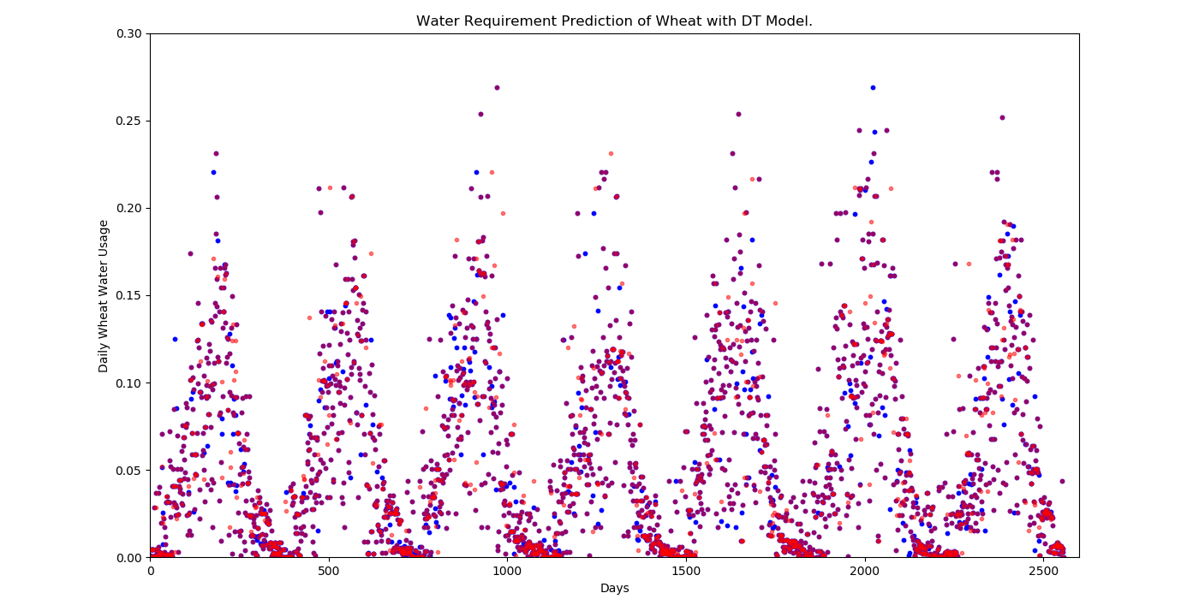
Fig. 7 Prediction of wheat with decision tree mode
In Fig.5, Fig.6 and Fig.7, We use all feature and label data works as training data, and we compare the prediction result with label values.
In those three figures, red dots are created by prediction values, and blue dots are created by label values, As we can
see, the prediction values are very close to label values, which means our model works well to predict the daily water usage of each crops.
- conclusion and future work
Since farmers do not know the weather and evapo-
transpiration in the few days later, they can not calculate the daily water usage by the formula mentioned in pre-data processing. However, we can predict the real daily water usage based on weather of that day by our model with low error. The predicted result provides a useful reference to farmers.
To get lower MAE, we plan to find other factors related to water usage as features. Finding more training data and trying other parameters in different models are also good ways to decrease the MAE^{[6]}.
References
- M.M. Al-Kaisi and I. Broner, Crop Water use and Growth Stages, Colarado State University
- Mohammad Valipour, Islamic Azad University, Temperature analysis of reference evapotranspiration models
- Murat Cobaner, Hatice Citakoglu, Tefaruk Haktanir and Ozgur Kisi, Modifying Hargreaves-Samani equation with meteorological variables for estimation of reference evapotranspiration in Turkey
- Khan, M., Islam, M. Z., & Hafeez, M. (2011). Irrigation Water Requirement Prediction through Various Data Mining Techniques Applied on a Carefully Pre-processed Dataset. Journal of Research and Practice in Information Technology, 43(22), 1-17.
- Iztok A. Pilih, Dunja Mladenic, Nada Lavrae, Tine S. Prevec3B. Smith, "Using Machine Learning for Outcome Prediction of Patients with Severe Head Injury", Tenth IEEE Symposium on Computer-Based Medical Systems.
- S. Atia, K. Shaalan, "Increasing the accuracy of opinion mining in Arabic", Proceeding of the 1st International conference on Arabic computing linguistics, pp. 06-113, 2015.

